Examples of schemes of placement a pallet in the container.
11 euro pallet (800 x 1200) in the 20-foot container.
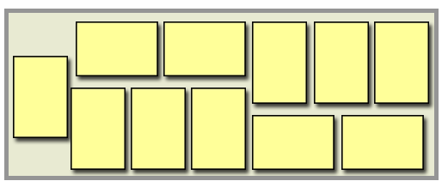
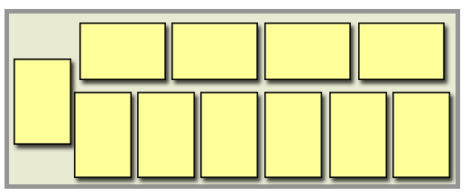
10 standard pallet (1000 x 1200) in the 20-foot container.
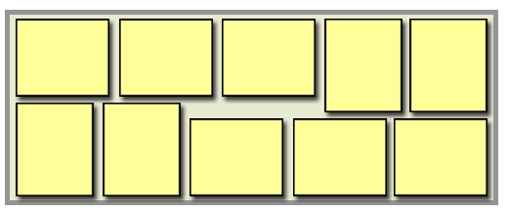
9 standard pallet (1000 x 1200) in the 20-foot container.
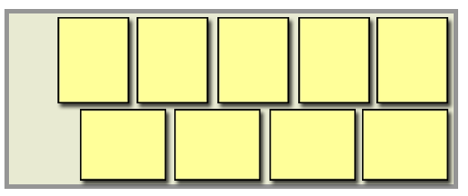
25 euro pallet (800 x 1200) in the 40-foot container.
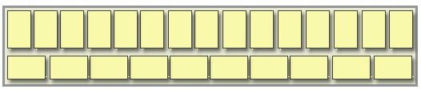
22 standard pallets (1000 x 1200) in the 40-foot container.
